Quickstart

*NOT:*

*Alla bilder är tagna från prototypserier, de slutliga produkterna kan komma att ha ett avvikande utseende*

The CodeLite application and the ARM cross compiler have already been installed on the Windows lab machines. If you want to install the software on your own computer there are download links listed at the end of this document.

Start the **CodeLite** program (found on the desktop on the lab machine).

Select ‘New Workspace’ from the File menu:

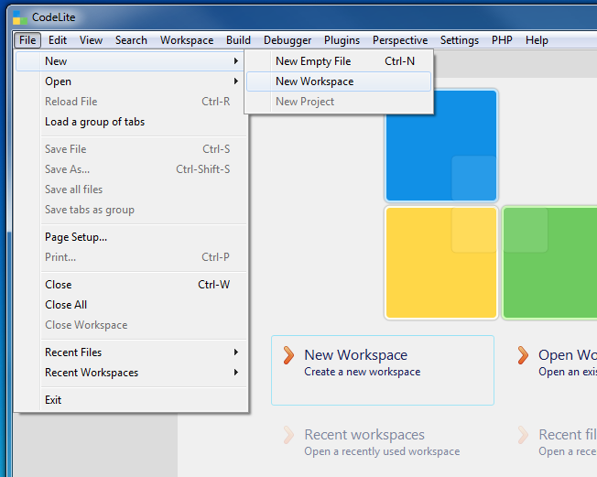

Select the ‘C++’ workspace type, and click ‘OK’:

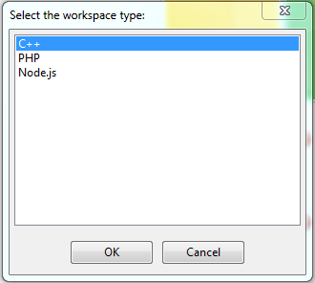

Select a location for the workspace directory (e.g., “Z:\Documents”),   
and name the new workspace “TinyTimber”. Then click ‘OK’:

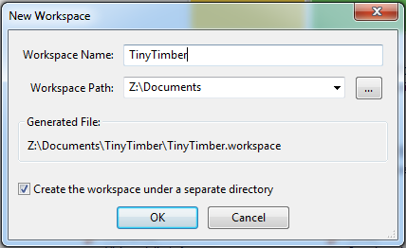

Download ‘RTS-Lab.zip’ from the course homepage into the workspace directory that you selected above (i.e., “Z:\Documents\TinyTimber”). Right-click on the file and select ‘Extract All’ to retrieve the project files to a project directory (i.e., “Z:\Documents\TinyTimber\RTS-Lab”):

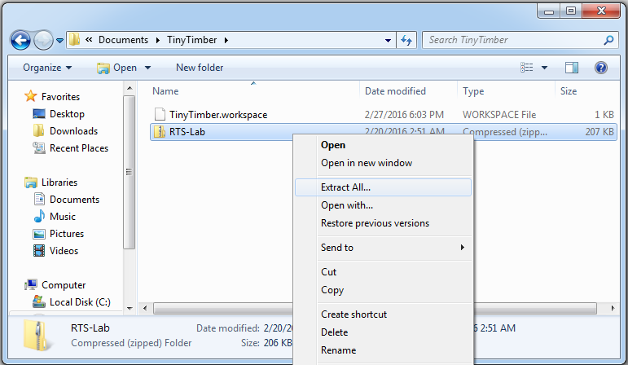

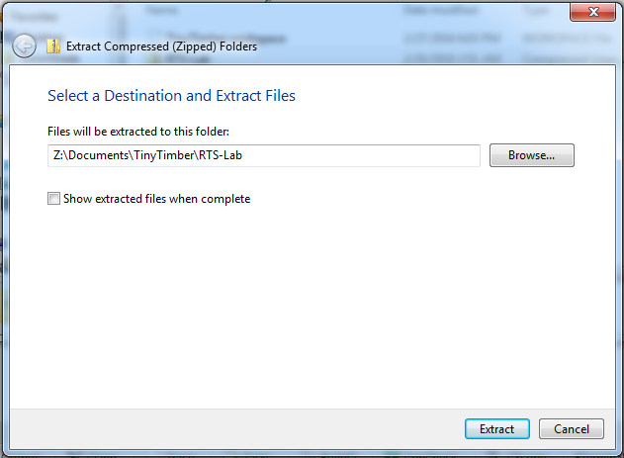

Right-click on the “TinyTimber” icon in the ‘Workspace View’ of CodeLite, and select ‘Add an existing project’ in the menu:

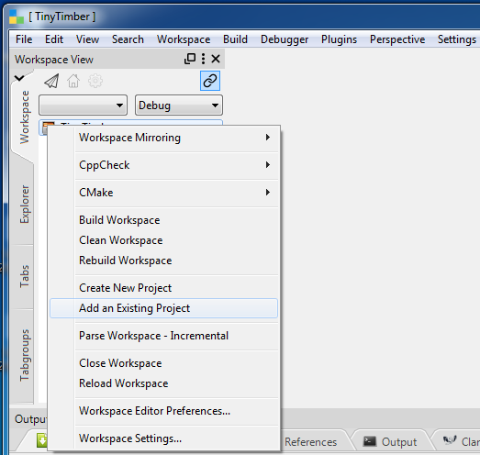

Browse to the project directory (i.e., “Z:\Documents\TinyTimber\RTS-Lab”) and select the file “RTS-Lab.project”. Then click ‘Open’:

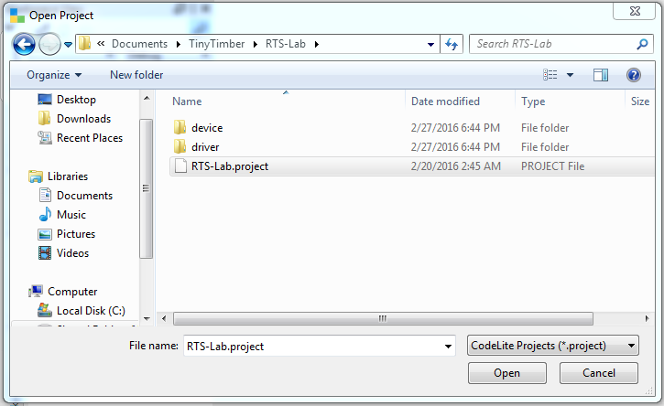

The project ‘RTS-Lab’ is now open. Click the small arrows to reveal the main project files. Double-click ‘application.c’ to start the CodeLite editor:

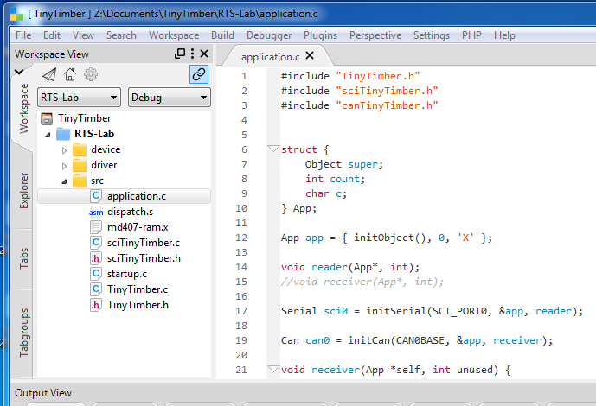

The ARM cross compiler is already the default compiler in CodeLite on the Windows lab machines. If you installed CodeLite and the cross compiler on your own computer use the instructions at the end of this document to set the default compiler.

The cross compiler software was configured (with suitable compiler and linker flags) when you loaded the project file, so you are now ready to compile your application program and download it to the MD407 card.

To create a load file for your target system choose ‘Build Project’ from the Build menu:

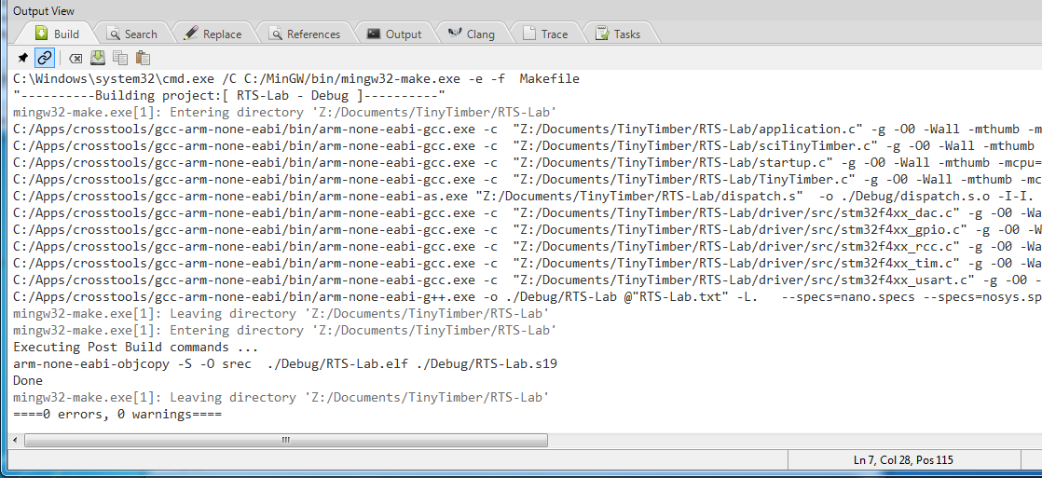

If everything has been configured correctly there should be 0 errors and 0 warnings from the project build. The load file (“RTS-Lab.s19”) has been created in the subdirectory ’Debug’ in your project directory.

Below we will describe how to download your application program using the CoolTerm console. If you want to use the console plugin in CodeLite or the Eterm standalone console instead, please follow the instructions at the end of this document.

Start the **CoolTerm** console (after downloading it from the Canvas page) and press the ‘Options’ button. Make sure that the port with the highest logical number (e.g., COM9) is selected and that the baudrate is set to 115200. Click ‘OK’:

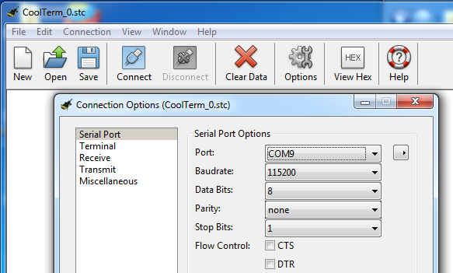

Click the ‘Connect’ button in CoolTerm to connect to the MD407 card, and then press the red ‘Reset’ switch on the card to start its embedded monitor software. The “dbg:“ prompter indicates that the monitor is ready to receive commands:

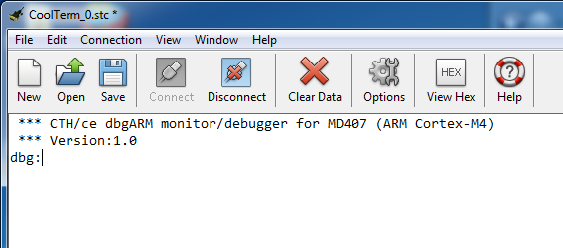

To download your application program to the MD407 card enter the monitor command “load”. After the monitor has printed the text “Loading”   
select ‘Send Textfile’ from the Connection menu in CoolTerm:

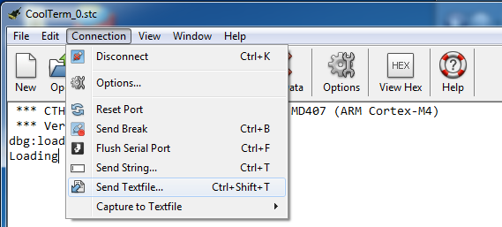

Browse to the subdirectory ‘Debug’ in the project directory and select the load file “RTS-Lab.s19”. Click ‘Open’. The load file will now be transferred to the MD407 card:

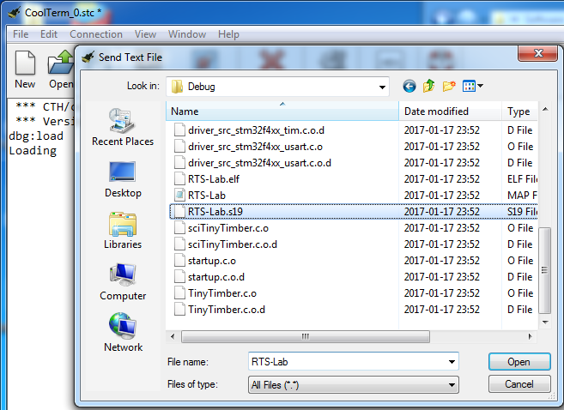

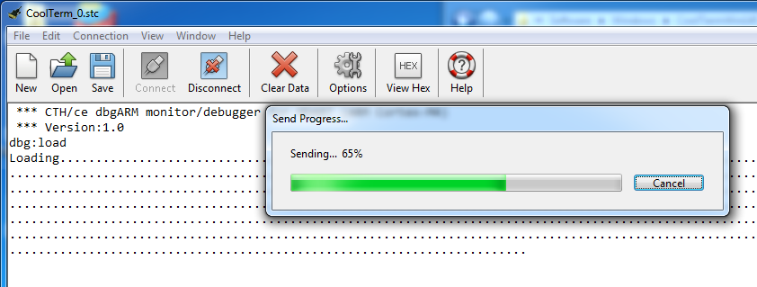

If the file transfer was successful your application program has been loaded into the RWM of the MD407 card, beginning at address 2000000016.

Execute your program by entering the monitor command “go 20000000”, and see the welcome text from the program. You are now ready to start developing your own code for the laboratory assignment:

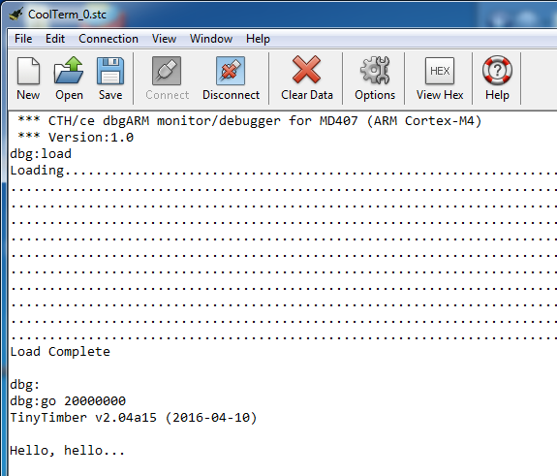

CodeLite console

This section describes how to activate the console plugin of CodeLite (available on Windows version 11.0.8.0-cse or earlier), and use it for downloading your application program to the MD407 card.

Locate the program **Device Manager** in the Windows Start menu search field and start the program by clicking on its icon in the search result list.

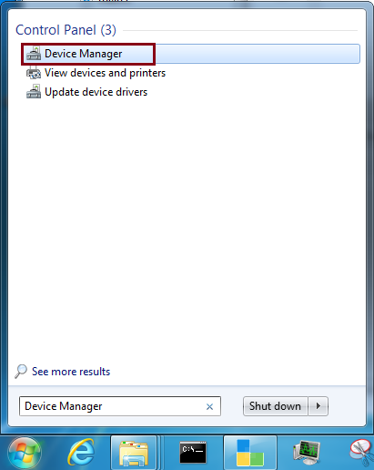

In Device Manager you will see a list of system device categories. Open the ‘Ports’ category by clicking on its small arrow. If the MD407 card has been connected properly there will be an entry for a unit type ‘USB Serial Port’. Make a note of the number ‘xx’ in the ‘COMxx’ name listed for that unit. In the picture below the number of interest is ‘9’ (taken from ‘COM9’)).

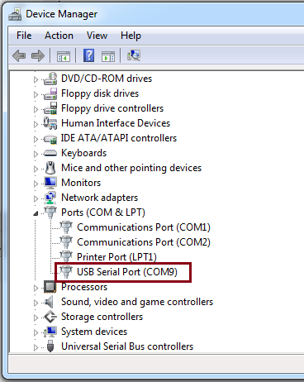

Close Device Manager and return to CodeLite.

In the Output View section of CodeLite select the ‘Eterm Console’ tab.   
A new set of buttons and a text input field will now appear at the top of   
the section window. Enter ‘\\.\COMxx’ in the text input field, where ‘xx’   
is the number you previously made a note of in Device Manager:

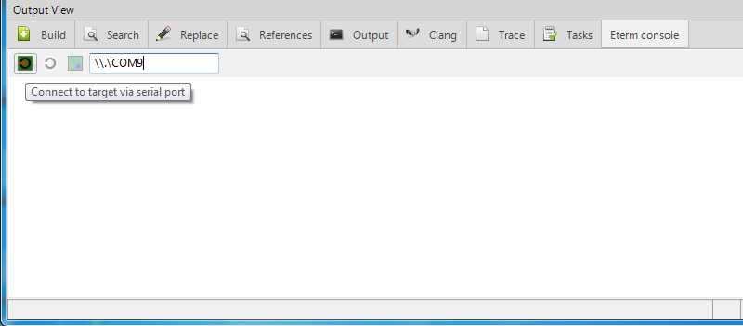

Click the leftmost button to connect to the MD407 card, and then press the red ‘Reset’ switch on the card to start its embedded monitor software. The “dbg:“ prompter indicates that the monitor is ready to receive commands:

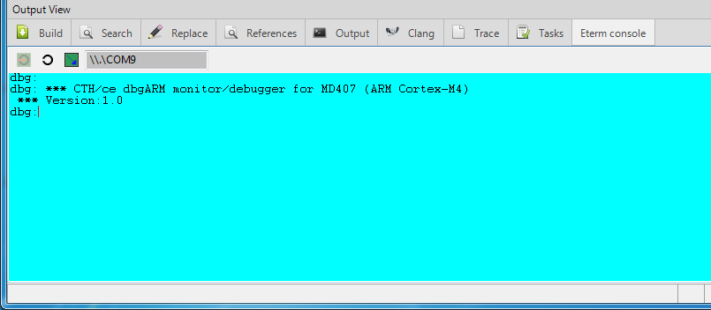

To download your application program to the MD407 card put the cursor in the blue window, right-click your mouse and select ‘Load’ from the menu:

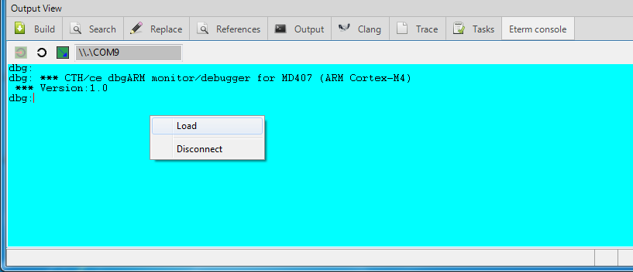

Browse to the subdirectory ‘Debug’ in the project directory and select the load file “RTS-Lab.s19”. Click ‘Open’. The load file will now be transferred to the MD407 card:

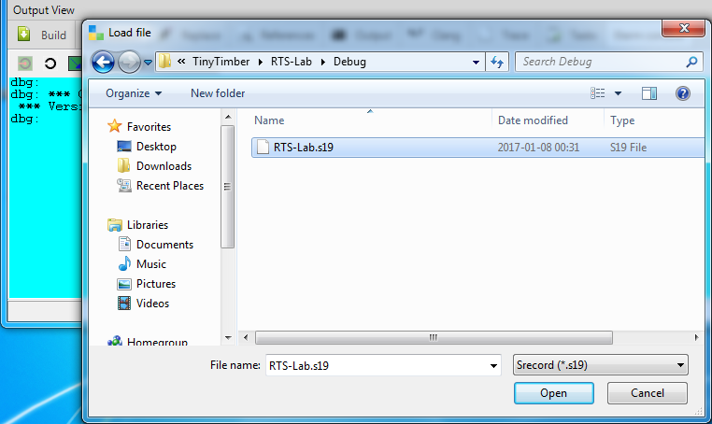

If the file transfer was successful your application program has been loaded into the RWM of the MD407 card, beginning at address 2000000016.

Execute your program by entering the monitor command “go 20000000”, and see the welcome text from the program. You are now ready to start developing your own code for the laboratory assignment:

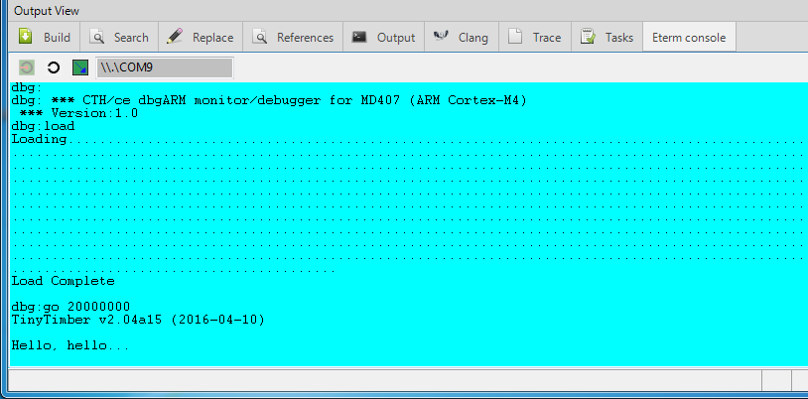

Eterm console

Recent versions of CodeLite (version 13.0.0-cse or later) do not contain   
the console plugin. Instead, the **Eterm** standalone console (found on the desktop on the lab machine) can be used for downloading your application program to the MD407 card. The procedure for connecting to the MD407 card and downloading your application program is almost identical to that of the CodeLite console plugin (see above).

Add compiler

Choose ‘Build Settings’ from the Settings menu in CodeLite, and verify that the selected compiler is “Cross GCC ( arm-none-eabi )”. If it is, then you are done.

Otherwise, choose ‘Add an existing compiler’ from the ‘Add Compilers’ dropdown menu (or press the green icon in later versions of CodeLite), and select the directory where the ARM cross compiler is installed (“C:\cseapp\CodeLite\tools\gcc-arm” on the most recent Windows lab machine configuration):

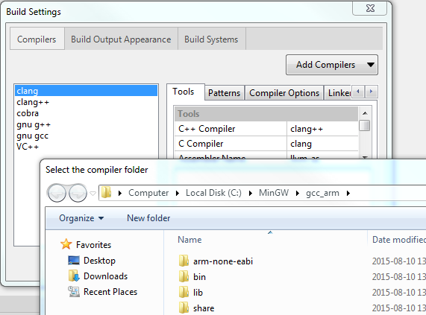

You should now get an acknowledgement that you have found the correct compiler:

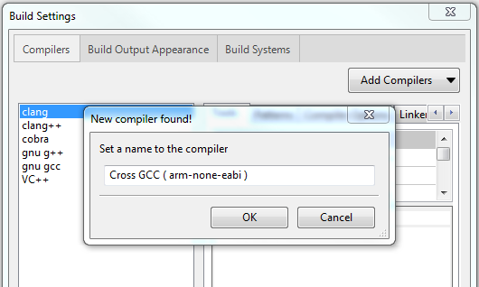

Select ‘OK’, and you are done.

More information

CodeLite open source web site:

<http://www.codelite.org>

GCC for ARM open source web site:

<developer.arm.com/open-source/gnu-toolchain/gnu-rm>

CoolTerm web site:

<http://freeware.the-meiers.org>